Report, to the trustees, of the visit of Dr Roger Sparrow to Grahamstown, South Africa, on Monday 12th November 2007.

“Something good can come for ordinary people”
Caleb Burgess, Good Shepherd School

These words spoken to his fellow pupils by Caleb on the receipt of his scholarship notification show an understanding of what we are doing for young people and demonstrate his potential leadership qualities by sharing his happiness with others.

The project to award a Harry Birrell Scholarship to a boy and a girl from the Good Shepherd School has gone ahead. Daphne and I planned our holiday so that we could visit Grahamstown and see the schools involved.
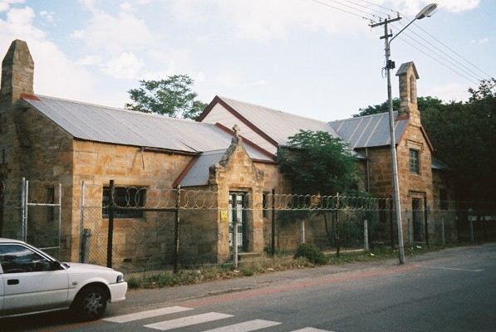

The Good Shepherd School, Grahamstown

Together with our hostess, Sylvia Birrell, we met Barbara Scott, the administrator of the Good Shepherd Trust at 8.45 am and then went to the Good Shepherd School. This school was built in the 1840’s and later extended. It had been run by nuns for poor children and has recently become a trust and the buildings owned by the trust. St Andrew’s College was involved in setting up the trust and supports the school in many ways. The school still educates local children and they are educated in English. They still come from the poorer parts of town. There are about 240 pupils and eight teachers, no administrative staff.

We saw the grounds where there are plans to build new classrooms, the planning stage can take some time. And then we entered the school. All was quiet and orderly, the pupils were all seated at a desk or table in close proximity with each other. There were displays on the wall, ranging from nursery rhymes, drawings by the pupils and examples of their work. All had a thick exercise book to work from and in most classes; evidence of learning was seen by the use of the blackboard. It is a Christian based school and there were examples, in the displays seen, that would foster a caring environment for all and with good behaviour.

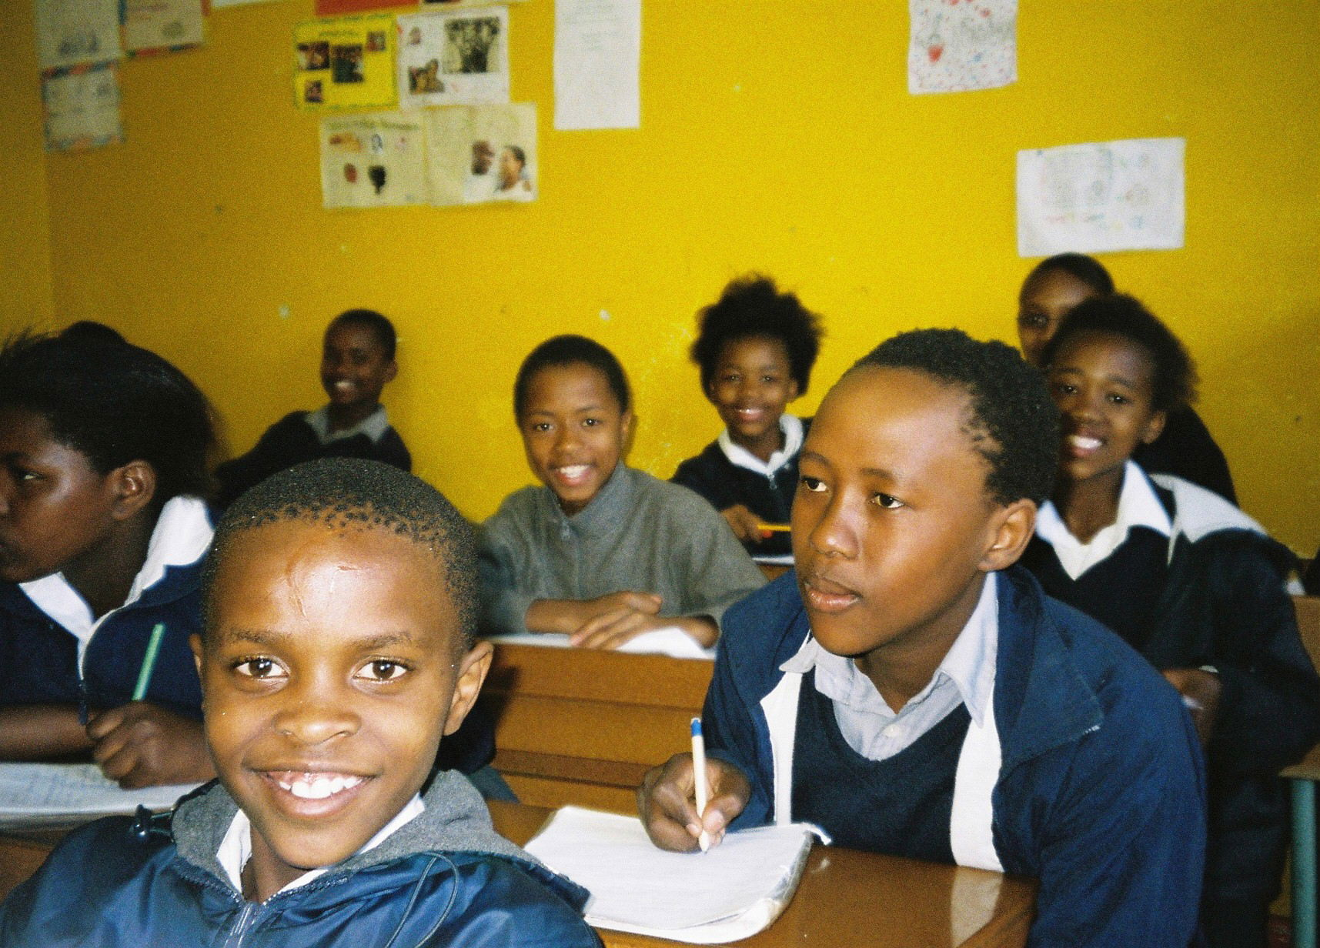

A class at the Good Shepherd School

When the new classes are built there are plans to join two classes, in the old building, together to make an assembly hall. At the moment there are also two temporary classrooms across the road. However the land is government land and earmarked for offices. They have been promised replacements in their own grounds but so far any promised work has not started.

After the tour of the school, Prudence Van der Linde, the head teacher asked me to present the notification letters to the two recipients of the scholarships. Abenathi Gqomo will go to Victoria Girls High School and Caleb Burgess will go to Graeme’s College next term.

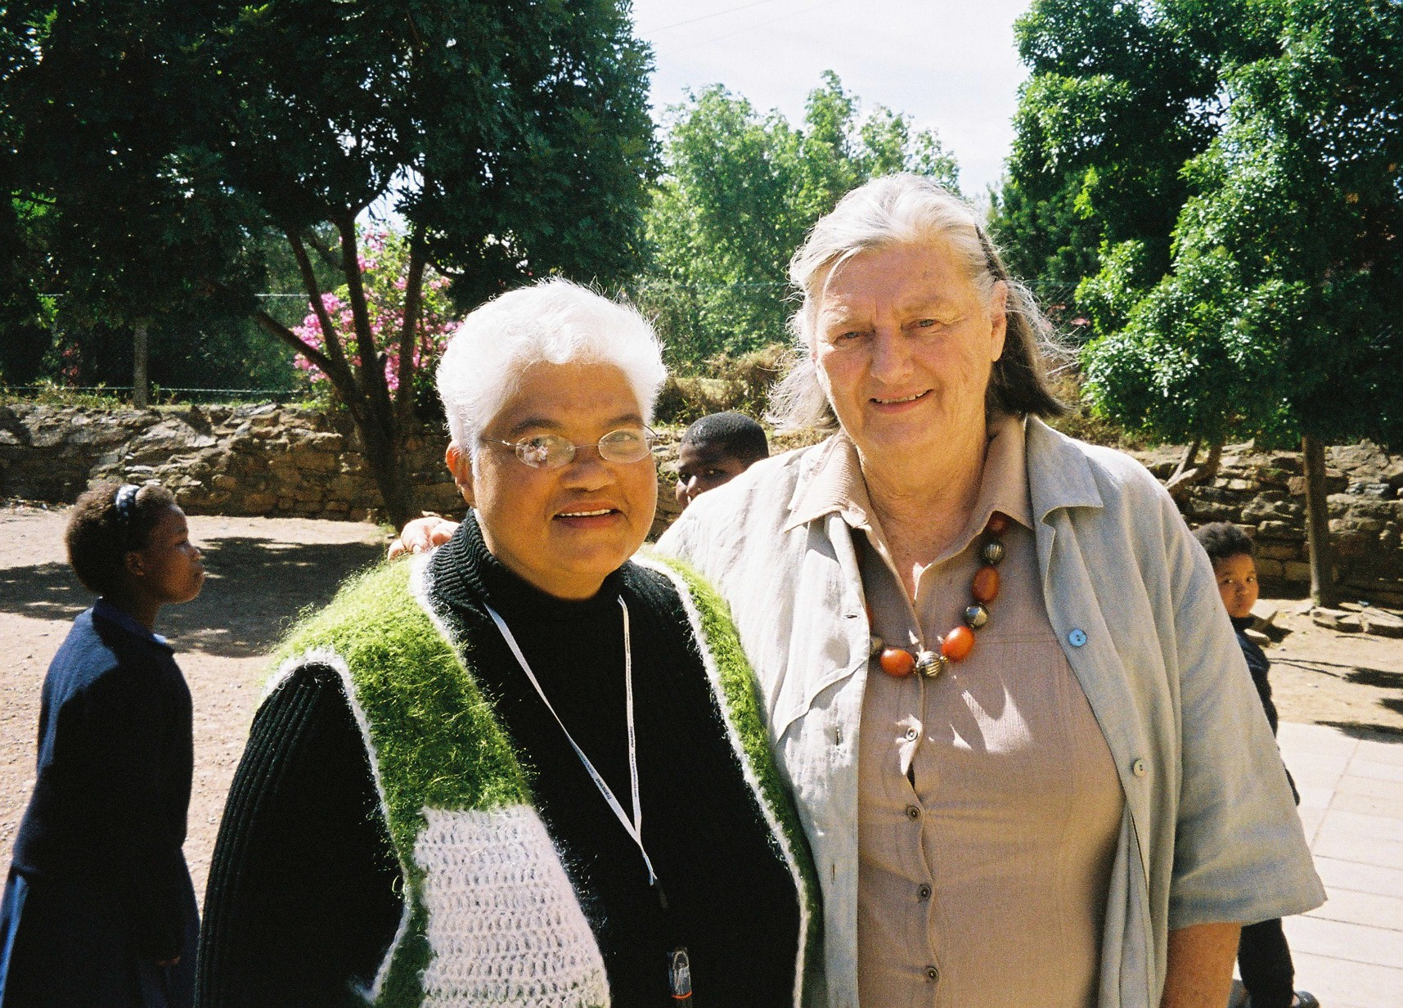
Prudence Van der Linde Sylvia Birrell

The presentation took place before the whole school, who had assembled outside. I was asked to say a few words and although unprepared I mentioned that Harry Birrell was someone who always encouraged pupils to make the most of their talents and that was the reason why there was a Harry Birrell Scholarship Trust. After the presentation, Abernathi and then Caleb both expressed their thanks to the trust. I took their photographs and then the school was dismissed after chanting their good behaviour song.

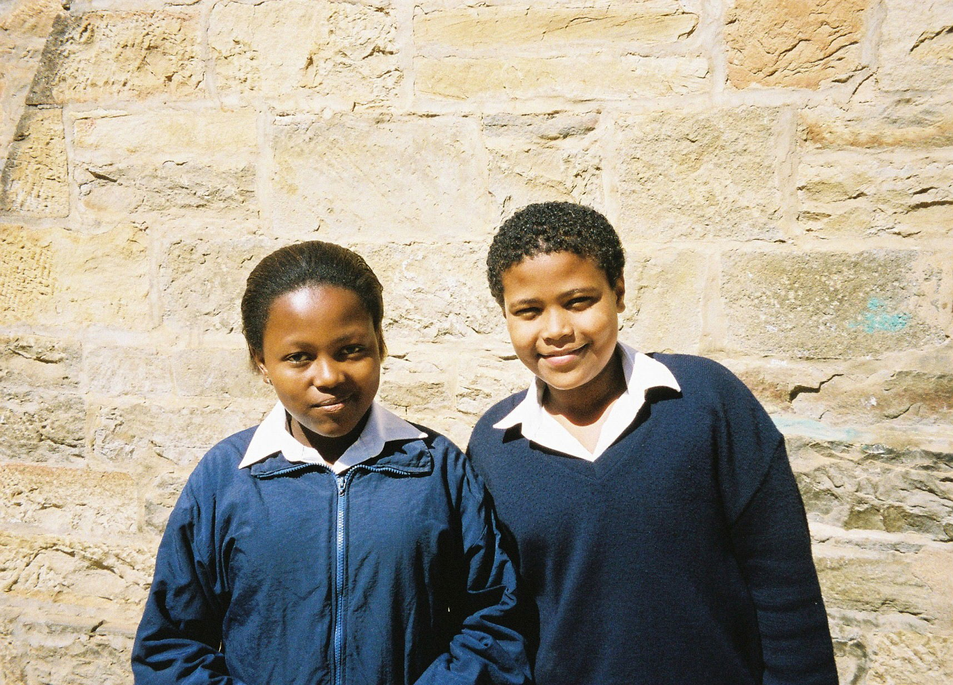
Abernathi Caleb

With my experience of being a primary school governor for over 35 years, I found the visit quite humbling. This is obviously a school which is well disciplined and pupils have an eagerness to learn. The facilities are sparse but there are dedicated staff who are able to inspire learners and ensure their spiritual development.

Our next stop was Victoria Girls High School. We were shown round by the deputy head’s wife who is also a teacher. The school was most impressive and had a computer suite, magnificent library and domestic science room equipped with electric cookers. The laboratories were spacious and equipped for all the usual experiments that would take place.

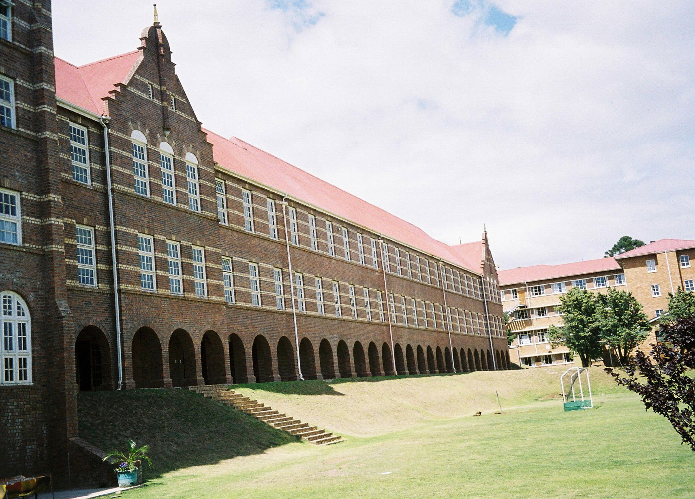

Victoria Girls High School

Graeme College had been on the same site as Victoria Girls High School but moved to the edge of town in the 1970’s and is housed in a modern building, just like many comprehensive schools in UK. There are extensive sports grounds and the school is well equipped with nice airy classrooms. We met Peter Reed the principal who impressed us. It seems that funding is a real problem and I found it hard to believe that he was able to keep such high standards with such a tight budget.
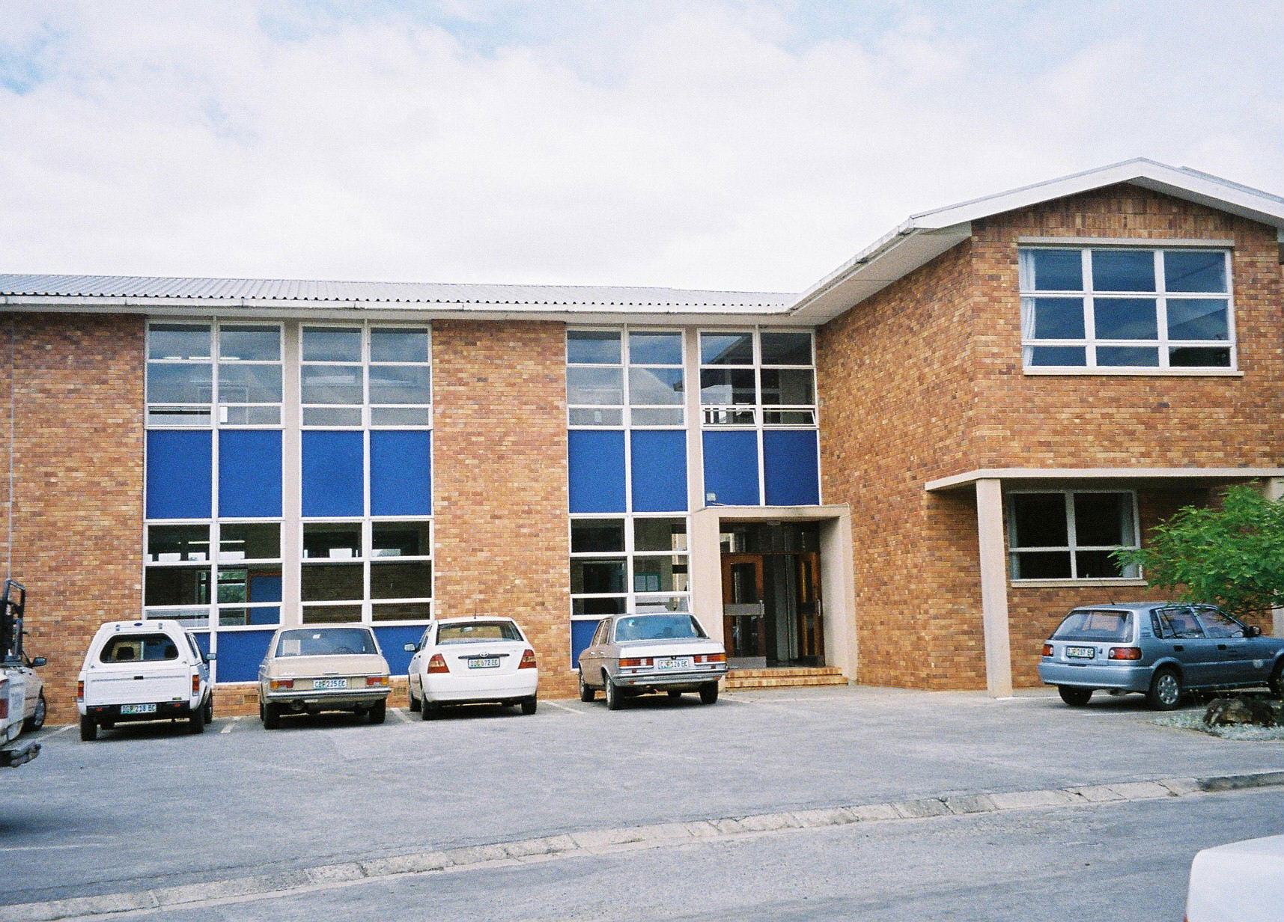
Graeme College

Both Graeme College and Victoria Girls High School have had pupils from the Good Shepherd in the past. These pupils had not been selected and there had been a lot of catching up to do in their first year. Peter Reed had met Caleb and thought that he would fit in. Having been selected on ability would help. Barbara Scott said that she would be available to help the two if they needed support.

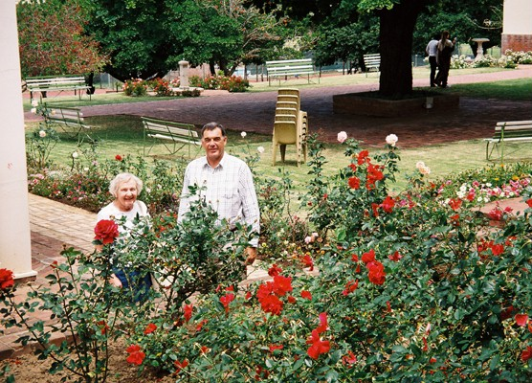

We then met Bruce Probyn (pictured above) the head of the Diocesan School for Girls. Another impressive head teacher and school. Bruce will be leaving soon and in his time at the school he is proud of the way he has improved the grounds surrounding the buildings. Flowers grow well and there is a landscaped memorial garden near the front entrance.

We also saw the chapel with its lovely stained glass windows and we got the impression that the needs of the pupils are catered for in the most extensive ways. We discussed the work and future direction of the trust.

Next was lunch. Sylvia hosted a lunch party at the Yellow Piano. This is a unique, to me, restaurant where the bill is calculated by the weight of the food taken. Anna Collett and Keagan Frisch, our present scholars joined us, as did Sylvia’s two granddaughters who are at DSG. Anna and Keagan will both go on to Stellenbosch University next year. Both the young people were well mannered and interesting to talk to. After lunch I took some photos.

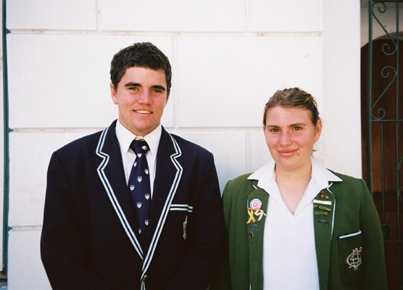

Keagan Anna

Our last school visit was to meet David Wylde, the head master of St Andrew’s College and Colin Armstrong, the bursar. We had a wide ranging discussion that included the work of the trust, the need to have an attractive profile to attract funds and how we would manage should revenue fail. We were shown round the school last year so there was not the need to see over it again and from our discussions it is clear that David Wylde is a most dedicated and impressive headmaster. We discussed the possibility of St Andrew’s having a boy from the Good Shepherd and it should not be ruled out if there was a suitable candidate. They are a caring school and would be able to make such a child welcome. I gave them our annual report and accounts. David Wylde was complimentary about Keagan who he rates as being very responsible and an example to others.

Then followed a short meeting with Barbara Scott, who promised to let me have contact details of those that I had met so I can thank them.

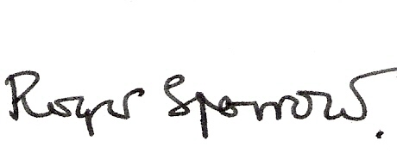

21 November 2007

Meirion House
Innings Lane
White Waltham
Maidenhead SL6 3RU

