[Addressee]
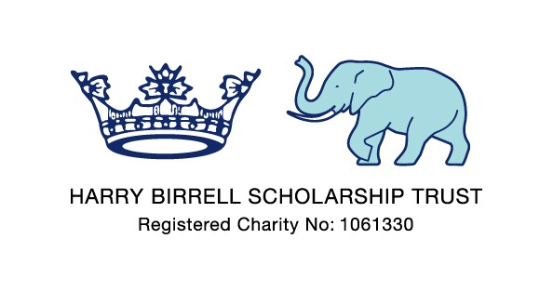
MEIRION HOUSE, INNINGS LANE, WHITE WALTHAM
MAIDENHEAD, BERKSHIRE SL6 3RU

Telephone: 01628 822693 E-mail: sparrow.doc@btinternet.com

[ ] September 2009

Dear [ ],

I wanted to write to thank everyone for their support at the launch of the Harry Birrell Scholarship Trust Patron’s Fund at St James’s Palace on the 30th July. It was a wonderful occasion in a magnificent setting, and gave our campaign a great start, attended by some [200] people. Our Patron, Peter Phillips, flew out from Hong Kong especially for the launch, having already initiated the campaign through his and Autumn’s very generous donation to the charity. We are very excited and appreciative of Peter’s support for the Harry Birrell Scholarship Trust, which is helping us to reach a new level in our activities.

The Trust was founded 12 years ago, and launched in Oxford with the help of a Classic Lions’ reunion rugby festival, on the same day that the 1997 Lions departed for South Africa. In 2009 the Lions once again toured South Africa, participating in a very competitive and closely fought encounter with the Springboks. Such long and colourful sporting traditions, between the peoples of the British Isles and South Africa, also reflect the very deep political, cultural and educational ties that exist between the nations. It is such ties that our charity is able to utilize, making every pound raised in the UK go a very long way in realising the Trust’s ambitions.

In short, our main ambition is to provide financial support for the provision of a quality education for talented yet poor children in South Africa, focused primarily on the Eastern Cape region of South Africa. Harry Birrell, who gave his name to our charity, taught for more than 30 years in the Eastern Cape and embodied the best of values shared between the countries of South Africa and the British Isles. He was a talented sportsman, attaining multiple blues for rugby and cricket at Oxford in the 1950s, but above all else he had a special gift in realising latent talent within individuals. We hope to continue this development of talent through the Trust.

The Trust’s primary partner in South Africa is The Good Shepherd School which is situated in Grahamstown, and is one of the oldest Anglican Primary Schools in South Africa. The Good Shepherd provides a quality primary school education for children from poor households in the Grahamstown location. Parents are only required to pay equivalent of GBP5 p.a. for a child to attend the school. Good Shepherd, since the decline of the Anglican Nuns’ Order that previously was responsible for its oversight, is managed in trust by St Andrew’s College, another Anglican school and one of South Africa’s leading independent schools. This trust arrangement for Good Shepherd is resulting in the upgrading of both its physical facilities and the quality of teaching and development provided to the Good Shepherd pupils. This process has created infrastructure which we are able to leverage off in ensuring our funds are put to use equitably and efficiently, in making a real difference to talented children whose parents cannot afford the fees for a quality secondary school.

Currently, the Harry Birrell Scholarship Trust finances an outdoor education programme at The Good Shepherd School (giving all the children at the school the experience of a 4 day expedition in the countryside which is something of a novelty for many urban children in South Africa), and provides full scholarships for a limited number of pupils at The Good Shepherd, who are offered senior school places in Grahamstown. At present we are financing Good Shepherd pupils who have attained places at Diocesan School for Girls, Victoria Girls High School and Graeme College. We also have a separate scholarship exclusive to St Andrew’s College.

The priority of the Trust going forward, and the basis of the newly established Patron’s Fund, is to increase the number of scholarships to Good Shepherd pupils offered places at secondary schools in Grahamstown. We anticipate that this will largely increase the number of scholars at Victoria Girls School and Graeme College, two good quality state schools where selection is on the basis of talent and, whilst school fees are considerably cheaper that independent schools such as DSG and St Andrew’s, requires a financial commitment of the equivalent of some GBP500 per annum per child.

This is where we need your continued support. We fully appreciate that we are living in challenging and uncertain economic times, and hope that we can encourage as wide a membership of the Friends of the Harry Birrell Scholarship Trust to spread the commitment to the Trust. Five Friends making a financial commitment of GBP100 a year each, allows us to send an additional deserving Good Shepherd pupil to a quality secondary school in Grahamstown.

We are therefore asking existing Friends to consider increasing their commitment to this GBP100 p.a. level, and new Friends of the Trust to join with a GBP100 p.a. commitment. Please see various payment options attached for this purpose. For the more ambitious (or those with access to corporate social responsibility budgets), you may want to consider making a more substantial one-off donation to the charity via the Birrell XI, of which details are also attached. All support is greatly appreciated, and with your continued support we are very excited at the opportunities that will be created for the Good Shepherd pupils by the Patron’s Fund initiative.

Yours sincerely

Stephen Sparrow
Chairman of Trustees

